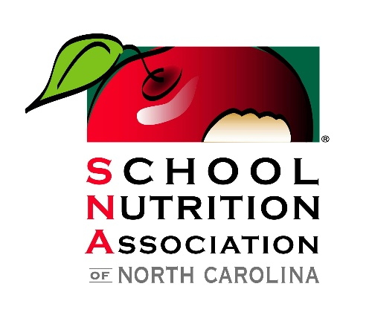

School Nutrition Association of North Carolina
2024 Industry Seminar
Hotel Ballast ~ Wilmington, NC
January 29-31, 2024
Tentative Agenda

Monday

12:00pm – 2:00pm Registration Open
2:00pm – 4:30pm Welcome & Opening Sessions
Financial Workshop with Janet Johnson
5:00pm --6:00pm Social with Cash Bar
Evening is Open for Dinner with Friends or Industry Partners

Tuesday

8:00am – 8:30am Registration Open
8:00am – 8:30am Light Continental Breakfast
8:30am – 11:30am NC DPI & NCDA Updates
General Session
Leadership for Success: Cultivating Emotional Intelligence in Ourselves and Those We Lead with Susan Cole
10:15am – 10:30am Beverage Break
11:45am – 12:30pm Golden Opportunities Networking Lunch
12:45pm – 2:45pm (6) Innovation Stations
3:00pm – 5:00pm (6) Innovation Stations
5:30pm – 6:00pm Social Hour with Cash Bar
6:00pm – 8:00pm Dinner

Wednesday

8:00am – 8:30am Light Continental Breakfast
9:00am – 12:00pm Table-Top Show
12:00pm – 12:12pm Break
12:15pm – 1:15pm Closing Session
Financial Workshop with Janet Johnson

